273/1
GEOGRAPHY
Paper 1
MAY 2016
Time: 2 hours 30 minutes

MOCK EXAMINATIONS 2016
UGANDA CERTICATE OF EDUCATION
GEOGRAPHY
PAPER 1
TIME: 2 HOURS 30 MINUTES

INSTRUCTIONS TO CANDIDATES

This paper consists of parts I and II.
Part I and section A of part II are compulsory.
Answer only one question from section B of part II.
Answers to all questions must be written in the answer booklet provided.

PART I

OBJECTIVE TYPE QUESTIONS
Answer all the 30 questions.
1. The Taita hills in Kenya were mainly formed by the process of
A. block uplift C. folding
B .volcanicity D. faulting

2. The Kano plains of Kenya are important for rice growing mainly because of the
A. abundant water for irrigation C. gentle slopes for easy mechanization
B. dense population to provide labour D. availability of vast land for cultivation

3. The lava plateaus of East Africa were mainly formed by
A. single eruptions of acidic lava C. fissure eruptions of basic lava
B. central vent eruptions of lava D. alternate eruptions of lava and ash

4. The major factor which influences rainfall distribution on the islands of Pemba and Zanzibar is
A. location at the equator C. movement of trade winds
B. the alignment of the coast D. height of land above sea level

5. The major economic activity which is carried out on the flood plains of river Manafwa is
A. fish farming C. agro forestry
B. irrigation farming D. livestock rearing

6. The major land use at altitudes of 2000-3000metres in the highlands of East Africa is
A. tourism C. forestry
B. settlement D. dairy farming

7. Which of the following areas in East Africa experiences a double maxima of rainfall
A. Kasese C. Butiaba
B. Bukoba D. Mombasa

8. The type of climate which is experienced in northern Uganda is
A. tropical desert C. modified equatorial
B. humid tropical D. tropical continental

9. Commercial ranching is well developed in central Uganda mainly because of
A. heavy rainfall C. ready market
B. abundant land D. reliable transport

10. The tea growers in western Uganda are mainly faced with the problem of
A. labour shortage C. inadequate capital
B. surplus production l D. declining soil fertility

11. The high population density in the southern highlands of Tanzania is mainly due to the
A. valuable mineral C. fertile volcanic soils
B. abundant rainfall D. developed transport

12. Cocoa growing in the southern highlands of Tanzania is mainly affected by
A. pests and disease C. high humidity levels
B. infertility of soil D. unstable market price

13. The mining activity which has caused extensive land degradation in East Africa is
A. limestone at Hima C. diamond at Mwadui
B. gold at Kakamega D. soda ash at Magadi

14. The high population density in the southern highlands of Tanzania is mainly caused by
A. rich mineral deposits C. high fertility of soils
B. well distributed rainfall D. well developed transport

15. The major cash crop grown in the West Nile region of Uganda is
A. coffee C. tobacco
B. cotton D. pyrethrum

16. The salt deposits in Lake Katwe have been formed by the process of
A. deposition of brine around hot springs C. precipitation due to hot temperatures
B. chemical weathering of volcanic plugs D. rivers flowing into inland drainage basin

17. The major process by which granitic rocks are weathered in East Africa is called
A. hydrolysis C. carbonation
B. hydration D. oxidation

18. The major effect of rice growing in the wetlands of eastern Uganda is
A. silting of river valleys C. spread of bilharzia disease
B. lowering of water tables D. destruction of wildlife habitats

19. The major problem caused by the deforestation of the upper slopes of Mt Ruwenzori is
A. lowering of water tables C. flooding of river valleys
B. destruction of wildlife habitats D. degradation of land

20. The location of cement industries in East Africa is mainly influenced by availability of
A. abundant raw materials C. cheap power supply
B. well developed transport D. large market potential

21. Which of the following mineral deposits are found in Kabale
A. iron ore and tin C. gold and phosphates
B. copper and limestone D. gypsum and fluorspar

22. The soft wood plantations are being promoted in East Africa mainly because they
A. provide for a variety of uses C. have short gestation periods
B. are resistant to diseases D. conserve marginal lands
23. The tourist industry in Tanzania has improved mainly because of
A. modernized accommodation C. gazetting of national parks
B. improvements in security D. developed transport network

24. The major threat to wildlife conservation in the Semliki National Park is
A. scarcity of surface water C. frequent earth quakes
B. poaching of animals D. grazing of livestock

25. Coral reefs are found along the East African coast because the water is
A. murky C. saline
B. muddy D. shallow

26. Which of the following methods is used for mining limestone in East Africa
A. adit C. drilling
B. dredging D. open-cast

27. The major problem limiting commercial fishing on Lake Albert is
A. steep escarpments C. limited market
B. limited fish species D. poor fishing gear

28. Which of the following national parks are found in Tanzania?
A. Tsavo and Marsabit C. Serengeti and Ruaha
B. Biharamulo and Meru D. Amboseli and Sibiloi.

29. The dominant tree species found in the Savanna woodlands of East Africa
A. have buttressed roots C. have smooth trunks
B. are umbrella shaped D. form a continuous canopy

30. The fishing method which is used for catching tuna along the East African coast is
A. trawling C. drifting
B. beach seining D. long lining

PART II
MAPWORK, PHOTOGRAPH INTERPRETATION, FIELD WORK AND EAST AFRICA

Answer four questions from part II, including questions 1, 2 and 3 which are compulsory.

SECTION A

- COMPULSORY QUESTION: MAPWORK.

Answer all parts of this question.

Study the 1:50,000 (UGANDA): NAMWENDWA map extract, Series Y732, part of sheet 62/2;Edition 1 – U.S.D and answer the questions that follow:

(a) Identify
(i) the man-made feature found at grid reference 278940
(ii) the physical feature found at grid reference 297052 (2 marks)

(c) (i) Measure and state in kilometers the distance of the dry weather road from the road junction at Naigobia (405911) to the road junction at Bunabala (389992). (1 marks)

(ii) Measure and state the bearing of the borehole at Buyoga (406036) from the water reservoir at Nabitakali (432085) (1 marks)

(d) Draw a cross section of the area between grid references 280920 and 330970 and on it mark and name the
(i) conical hill
(ii) river Nalusi
(iii) seasonal swamp
(iv) dry weather road
(v) district boundary (7 marks)

(e) Describe the:
(i) relief of the area, (5 marks)
(ii) relationship between relief and drainage
in the area shown in the map extract. (4 marks)

- COMPULSORY QUESTION: PHOTOGRAPHIC INTERPRETATION.
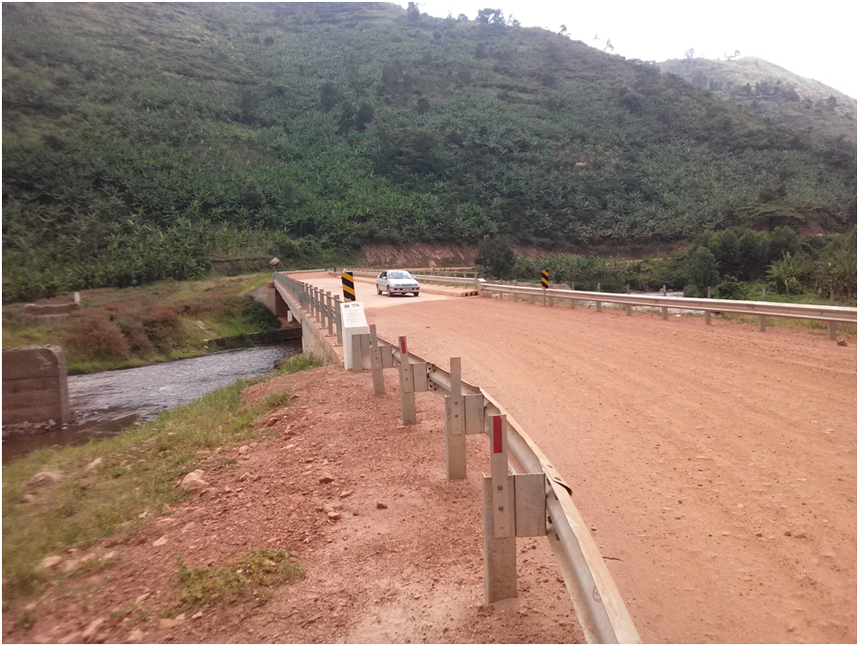
Study the photograph provided below and answer the questions that follow:

(a) Draw a sketch of the area shown on the photograph and on it, mark and name:
(i) highland
(ii) broad valley
(iii) crop land
(iv) bridge (5 mark)

(b) Explain the factors that have favoured the establishment of the type of transport shown in the photograph. (4 marks)

(c) Explain the benefits of the drainage feature shown in the photograph to the people living in this area . (4 marks)

(d) Giving reasons for your answer, suggest one area in East Africa where this photograph could have been taken. (2 marks)

3. COMPULSORY QUESTION: FIELDWORK
For any one fieldwork study you have carried out on a farm or small scale industry :
(a) State the:
(i) topic of your study (2 marks)
(ii) objectives of your field work study. (3 marks)
(b) Describe the activities you carried out before going out for the field work study.
(4 marks )
(c) Draw a sketchmap to show the location of the farm or small scale industry in the area studied. (3 marks)
(d) Explain the influence of the farm or small scale industry to the surrounding areas.
(3 marks)

SECTION B: EAST AFRICA (20 MARKS)

Answer only one question from this section.

4. (a) (i) What is meant by a delta? (3 marks)
(ii) Name any two rivers in East Africa which have deltas. (2 marks)

(b) Describe the conditions which have led to the formation of deltas in East Africa.
(6 marks)
(c) Explain the benefits of deltas to the people of East Africa. (5 marks)

(d) Outline the problems faced in the utilization of rivers in East Africa. (4 marks)

5. Study the table below showing land area and population size of the East African countries in the years 1990,2006 and 2015 and answer the questions that follow:

East Africa: Land Area and Population Size
Country | Land area (km²⁾ | Year
Country | Land area (km²⁾ | 1990 | 2006 | 2015
Uganda  Kenya  Tanzania | 197,000  569,000  884,000 | 17,800,000  23,400,000  25,500,000 | 29,900,000  36,600,000  39,500,000 | 40,700,000  46,100,000  48,900,000
Adapted: Africa Development Indicators, 2007 (p.21)World Development Indicators 2008 Pp 40-41. The World Bank Washington D.C.

(a) Calculate the:
(i) population densities of each of these countries for the year 2015. (3 marks)
(ii) percentage change in the population of each country between 1990 and 2015.
(3 marks)
(b) Draw a line graph to show the population trend of the country with the fastest population growth in between 1990 and 2015. (6 marks)
(c) Explain the advantages of a high population density in any one country of East Africa.
(4 marks)
(d) Outline the steps being taken to solve the problem of high population density in East Africa. (4 marks)

6.(a) Draw a sketch map of East Africa and on it mark and name:

(i) Water bodies: Rufiji and Tana
(ii) Hydro Electricity Stations : Kindaruma and Mtera
(iii) Industrial Towns: Mombasa and Mwanza. (7 marks)

(b) Describe the factors which have promoted the development of industries in Tanzania.
(6 marks)

(c) Explain the problems facing the industrial sector in Tanzania . (4 marks)

(d) Outline the effects of industrial development on the environment in East Africa.
(3 marks)

7. Study the table below showing in-bound international tourists in East Africa (1995-2006) and answer the questions that follow:

In-bound international tourists to East Africa
Country | 1995 | 2006
Tanzania  Kenya  Uganda | 285,000  896,000  160,000 | 622,000  1,536,000  539,000
Total | 1,341,000 | 2,697,000

Adapted: World Development Indicators(2008). The World Bank , Washington D.C.Pp377-378.
(a) Calculate the trend of the in-bound international tourists for each country in East Africa between 1995 and 2006. (6 marks)

(b) Draw a bar graph to show the in-bound international tourists to East Africa in the year 2006. (5 marks)
(c) Describe the factors which have contributed to the trend of in- bound international tourists to East Africa shown in the table above. (6 marks)

(d) Outline the problems faced by the tourist industry in East Africa. (3 marks)

_ END_

